  - STRATEGIES
Connect the Dots

Make a connection between the ideas at the end of the arrows. How are they the same? How are they different?

Parallelogram
Rectangle

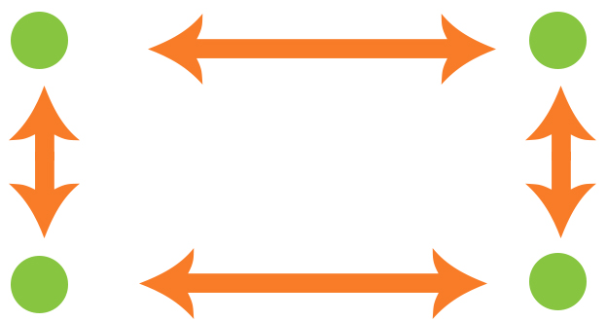
Rhombus
Square

